Sulz am Neckar, September 2021

New at KIPP: Wheels and rollers for industrial applications

HEINRICH KIPP WERK has incorporated a wide selection of high quality wheels and rollers into its product range. The product range extends from heavy-duty castors for industrial trucks to guide rollers used in logistical applications such as packaging lines or conveyor systems. High quality standards ensure optimum running performance and high system reliability in every application.

The comprehensive KIPP range also includes special products for specific requirements. For example, wheels and castors with a thin, high-quality tread with optimised geometry are ideal for easy handling in intralogistics. They are designed for high speeds and low roll and swivel resistance. Even heavy loads can be effortlessly moved and steered manually.

But robust wheels and castors are also in demand aside from the "classic" application fields such as intralogistics and machine and plant construction. This gives rise to special requirements, which KIPP meets with its wide product range. For example, components in the food industry have to comply with particularly strict hygiene regulations and withstand frequent cleaning processes with sometimes aggressive chemicals. For this purpose, KIPP offers a series in which white wheel bodies with a light blue tread make contamination easily visible. Stainless steel wheel versions are also available for use in corrosive environments.

The antistatic wheels and rollers from the KIPP range are suitable for environments where electrical discharges must be avoided. Particularly noteworthy are models equipped with special tyres made of grey elastic solid rubber. They do not cause any marks on the floor and so, not only reduce the risk of injury and damage from electric shocks, but also simultaneously improve cleanliness in their respective areas of use.

The same "non-marking grey" tread are also features of high cushioning wheels and castors, which are designed for transporting goods that are sensitive to impact. A thick coating with an adapted contour reliably cushions surface irregularities and ensures particularly smooth running.

At KIPP, wheels and rollers are part of the main group Material Handling, in which ball transfer units and ring bolts are also available.

(Characters including spaces: 2,278)

Image overview:
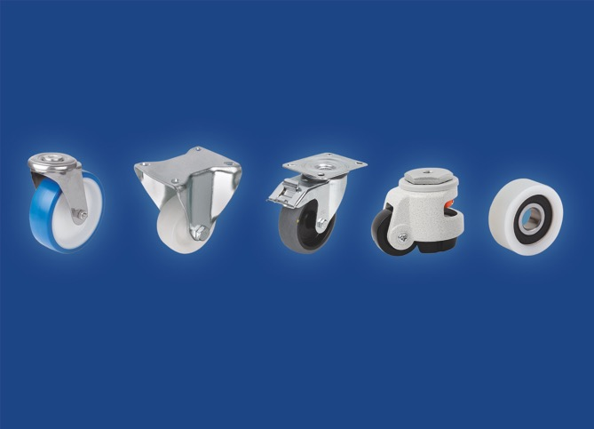
HEINRICH KIPP WERK has incorporated a wide selection of high quality wheels and rollers into its product range.
Image: HEINRICH KIPP WERK GmbH & Co. KG

HEINRICH KIPP WERK GmbH & Co. KG
Stefanie Beck, Marketing
Heubergstrasse 2
72172 Sulz am Neckar

Telephone: +49 7454 793-30
Email: stefanie.beck@kipp.com

