Sulz am Neckar, March 2021

Building responsibly:
KIPP uses "green steel" for its new logistics building

HEINRICH KIPP WERK expands the logistics at its headquarters in Sulz am Neckar. The distinctive feature: only CO2-neutral reinforcing steel is used in the project. The new building is thus in a double sense a sustainable investment in the future.

"We are focusing on long-term growth", emphasises KIPP's Managing Director Nicolas Kipp. „Once again, we are committed to sustainable action and support climate protection with CO2-neutral steel. "The new building will comprise a logistics extension with shuttle storage, a commissioning area, offices and a staff lounge over a total area of 4,300 m2. 400 tonnes of reinforcing steel are needed for the new building. The decision was made in favour of certified "green steel" from SÜLZLE Stahlpartner in Rosenfeld.

CO2-Belastungen bei der Stahlherstellung gleicht KIPP dabei durch einen Kompensationsbeitrag aus. Bestätigt wird dies durch eine Urkunde, welche Heinrich Sülzle an die Bauherren Nicolas und Heinrich Kipp übergeben hat. Mit dem Klimabeitrag werden Projekte sowohl regional als auch in Schwellen- und Entwicklungsländern unterstützt – zum Beispiel in den Bereichen Waldschutzaufforstung in Uruguay, Photovoltaik in Indien und Trinkwasser in Simbabwe.

SÜLZLE is the first supplier of certified "green steel" in Germany. „Innovative and leading companies have a high awareness of climate protection and sustainability," says Michael Frey of architects Schmelzle+Partner, who is overseeing KIPP's new building project. "By using CO2-neutral structural steel, HEINRICH KIPP WERK realises sustainable construction and thereby supports global renewable energy projects."

(Characters including spaces: 1,724)

Image overview:

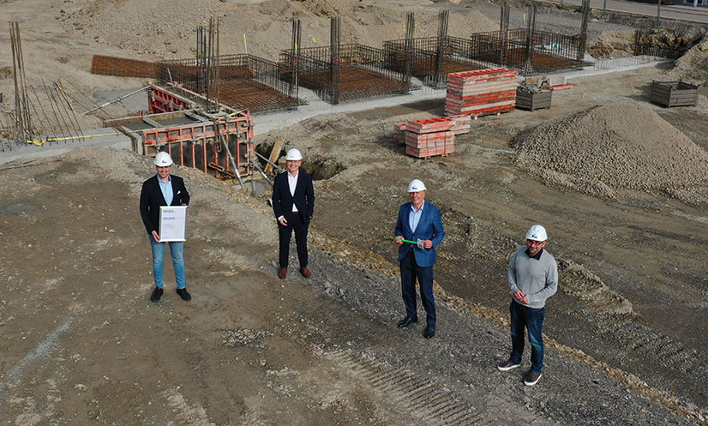

KIPP-Logistikerweiterung.jpg: Presentation of the "CO2-neutral steel" certificate at the HEINRICH KIPP WERK construction site. (from L to R Nicolas Kipp, Heinrich Sülzle, Heinrich Kipp, Tobias Bronner)

HEINRICH KIPP WERK GmbH & Co. KG
Stefanie Beck, Marketing
Heubergstraße 2
72172 Sulz am Neckar

Telephone: 07454 793-30
E-Mail: stefanie.beck@kipp.com

